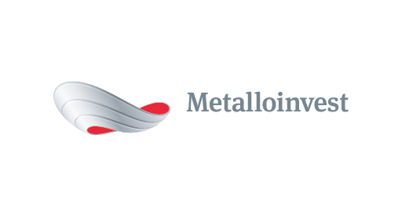 PRESS RELEASE

Metalloinvest discusses freight transport partnership opportunities
31 August 2017, Moscow – A meeting has taken place at Lebedinsky GOK (part of Metalloinvest) to discuss Metalloinvest enterprises' partnership with the rolling stock operating company New Forwarding Company (part of Globaltrans Group), specifically focusing on issues relating to freight transport organisation in the current year, as well as from 2018-2019. Participants in the meeting included: representatives of Management Company Metalloinvest, Lebedinsky GOK, Mikhailovsky GOK, OEMK, Ural Steel and Ural Scrap Company, as well as the operating company. The meeting was led by Nazim Efendiev, First Deputy CEO, Sales Director, Management Company Metalloinvest.
The meeting participants reviewed the efficiency and quality of the partnership and discussed the current issues around the organisation of cargo flows and how to resolve them, as well as the prospects for the partnership from 2017-2019.
In 2016, approximately 40 mn tonnes of finished products were delivered from the Metalloinvest enterprises Lebedinsky GOK, Mikhailovsky GOK, OEMK and Ural Steel, while this figure stands at over 22 mn for the first seven months of 2017.
Nazim Efendiev, First Deputy CEO, Sales Director, Management Company Metalloinvest, commented: "We are satisfied with the quality of our work together with our longstanding partner New Forwarding Company, a leader in the Russian rolling stock operating market that has supplied rolling stock to deliver Metalloinvest products for over five years. In this now-traditional meeting to review issues relating to freight transport services for Metalloinvest enterprises, we discussed medium-term changes to the structure of the Company's merchant product cargo flows."
# # #
Metalloinvest is a leading global iron ore and merchant HBI producer and supplier, and one of the regional producers of high-quality steel. The Company has the world's second-largest measured iron ore reserve base and is one of the lowest-cost iron ore producers.
Metalloinvest is wholly owned by USM Holdings. Alisher Usmanov is the major beneficiary of USM Holdings (49%), with other major beneficiaries being the companies of Vladimir Skoch (30%) and Farhad Moshiri (10%).

For further information, please contact:
Corporate Communications Department
Dmitry Kravchenko
+7 (495) 981-55-55
pr@metalloinvest.com

