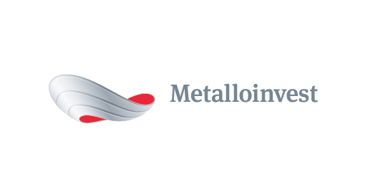 PRESS RELEASE
Metalloinvest wins Russian Business Leaders: Performance and Responsibility 2015 contest
24 March 2016, Moscow – Metalloinvest has been victorious at the “Russian Business Leaders: Performance and Responsibility – 2015” nationwide contest, winning the “For contributions to solving regional social problems” category. The winners were announced as part of Russian Business Week.
Metalloinvest adheres to overarching principles of corporate social responsibility in the implementation of its programmes, which are aimed at maintaining and developing a favourable socio-cultural environment in the towns where the Company operates in the Belgorod, Kursk and Orenburg regions. Together with regional administrations, the Company improves the working and living conditions of its employees and local residents, taking into account the specifics of local communities. The programmes are implemented in the form of public-private partnerships under socio-economic partnership agreements with local regional governments.
Andrey Varichev, CEO of Management Company Metalloinvest, commented: “Social responsibility is a core part of Metalloinvest’s business. We seek to adhere to best practice in our sustainable development projects, as we regard corporate social programmes as investments in our future. Improving people’s quality of life and protecting the environment in the regions where we operate remain key priorities for our Company”.
The “Russian Business Leaders: Performance and Responsibility” nationwide contest is an annual event aimed at promoting the sustainable development of companies, which are of strategic importance to Russia’s economic development. The contest identifies rapidly developing companies based on their economic and social indicators for the reporting year. The competition is organised by the Russian Union of Industrialists and Entrepreneurs.
# # #
Metalloinvest (www.metalloinvest.com) is a leading global iron ore and HBI producer and supplier, and one of the regional high quality steel producers. The Company has the world’s second largest measured iron ore reserve base under its operation with the key-note iron ore production cost efficiency.

Metalloinvest is wholly owned by USM Holdings. Alisher Usmanov is the major beneficiary of USM Holdings (48%), with other major beneficiaries being the companies of Vladimir Skoch (30%) and Farhad Moshiri (10%).

For further information, please contact:
Corporate Communications Department
Dmitry Kravchenko
+7 (495) 981-55-55
pr@metalloinvest.com

