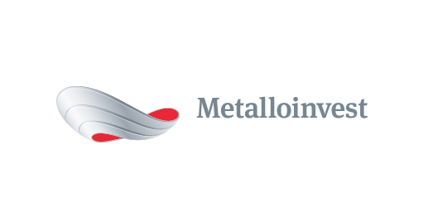 PRESS RELEASE

Metalloinvest supplies rolled steel for bridge over the Kama River
10 June 2016, Moscow – Ural Steel (part of Metalloinvest) has supplied over 95% of all rolled steel used for the construction of a new bridge over the Kama River.
The bridge, which is over 1 km long, will become part of the highway Izhevsk-Sarapul-Kambarka. The opening of the bridge is planned for autumn 2016, and the bridge will be in use by technical transport from June. The bridge construction elements are produced by Tyumenstalmost LLC.
The construction of the bridge over the Kama River has a significant importance for the development of the Central, Volga and Ural Federal Districts. It will increase the transit potential of the regions and free up traffic flows of the federal highways M5 and M7.
Metalloinvest is the largest manufacturer and supplier of high-quality steel for the Russian bridge construction industry. In recent years, many iconic structures in Russia have been built using steel from Ural Steel, confirming the high quality of the Company’s products and reliability of supplies. In addition to the bridge over the Kama River, Metalloinvest has supplied steel for the construction of other large bridges in Russia, including the bridge to Russky Island in Vladivostok, the Bugrinsky Bridge in Novosibirsk, a bridge over the Oka River in Nizhny Novgorod and a bridge over the Nadym River, which connected the Yamal Peninsula with Central Russia and the Urals. The Company also supplied steel for the construction of Sochi Olympic facilities (Fischt Olympic Stadium, among others), as well as the Otkritie Arena, the home stadium of Spartak Moscow football club.
# # #
Metalloinvest (www.metalloinvest.com) is a leading global iron ore and HBI producer and supplier, and one of the regional high quality steel producers. The Company has the world’s second largest measured iron ore reserve base under its operation with the key-note iron ore production cost efficiency.

Metalloinvest is wholly owned by USM Holdings. Alisher Usmanov is the major beneficiary of USM Holdings (48%), with other major beneficiaries being the companies of Vladimir Skoch (30%) and Farhad Moshiri (10%).

For further information, please contact:
Corporate Communications Department
Dmitry Kravchenko
+7 (495) 981-55-55
pr@metalloinvest.com

