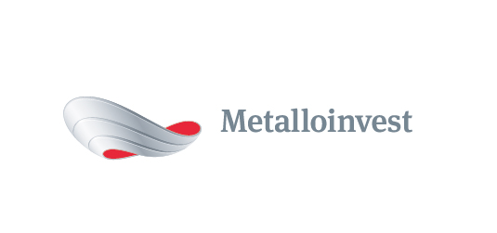 PRESS RELEASE

Metalloinvest signs long-term contracts with Evraz for supply of iron ore products

7 August 2017, Moscow - Metalloinvest and Evraz have signed new long-term contracts for the supply of 3.4 mn tonnes of iron ore and pellets.
The contracts stipulate that Mikhailovsky GOK (part of Metalloinvest) will supply Evraz with 1.6 mn tonnes of pellets and 1.8 mn tonnes of iron ore concentrate before 30 June 2018.
Nazim Efendiev, First Deputy CEO, Sales Director, Management Company Metalloinvest, commented: “Supplying high-quality iron ore products to Russian steel companies on long-term contracts is a permanent priority for Metalloinvest. Metalloinvest and Evraz have been partners for many years, and our relationship is based on each party conscientiously implementing its commitments, as well as an understanding of our mutual interests.”

# # #
Metalloinvest is a leading global iron ore and merchant HBI producer and supplier, and one of the regional producers of high-quality steel. The Company has the world's second-largest measured iron ore reserve base and is one of the lowest-cost iron ore producers.
Metalloinvest is wholly owned by USM Holdings. Alisher Usmanov is the major beneficiary of USM Holdings (49%), with other major beneficiaries being the companies of Vladimir Skoch (30%) and Farhad Moshiri (10%).

For further information, please contact:
Corporate Communications Department
Dmitry Kravchenko
+7 (495) 981-55-55
pr@metalloinvest.com

