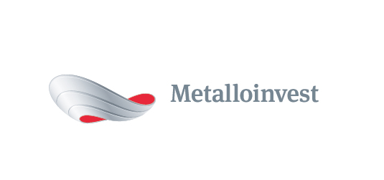 PRESS RELEASE

Metalloinvest signs long-term contracts with Mechel for supply of iron ore products

10 August 2017, Moscow – Metalloinvest and Chelyabinsk Metallurgical Plant (part of Mechel) have signed long-term contracts for the delivery of approximately 1.6 mn tonnes of iron ore and pellets.
The contract stipulates that Mikhailovsky GOK (part of Metalloinvest) will supply 0.6 mn tonnes of pellets and 1 mn tonnes of iron ore concentrate and sintering ore to Chelyabinsk Metallurgical Plant before 30 June 2018.
Pricing will be determined through a formula based on market indicators for iron ore prices in both global and domestic markets. The contracts with Mechel add to the list of Metalloinvest's long-term agreements for the supply of iron-ore products to leading Russian steel companies.
Andrey Prosyanik, Director of Domestic Sales, Management Company Metalloinvest, commented: "These new long-term contracts are a testament to the high level of trust between Metalloinvest and Mechel. Metalloinvest values its partnership relationships with its customers and devotes special attention to the quality of its products and the timeliness of deliveries."
Anatoly Shchetinin, Managing Director, Chelyabinsk Metallurgical Plant, added: "This contract will ensure that Chelyabinsk Metallurgical Plant receives high-quality iron ore, which guarantees the sustainable operation of the enterprise and the stable implementation of its production programmes."

# # #
Metalloinvest is a leading global iron ore and merchant HBI producer and supplier, and one of the regional producers of high-quality steel. The Company has the world's second-largest measured iron ore reserve base and is one of the lowest-cost iron ore producers.
Metalloinvest is wholly owned by USM Holdings. Alisher Usmanov is the major beneficiary of USM Holdings (49%), with other major beneficiaries being the companies of Vladimir Skoch (30%) and Farhad Moshiri (10%).

For further information, please contact:
Corporate Communications Department
Dmitry Kravchenko
+7 (495) 981-55-55
pr@metalloinvest.com

