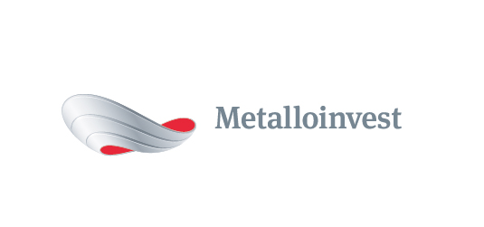 PRESS RELEASE

OEMK completes construction of another environmental facility

11 August 2017, Moscow – OEMK (part of Metalloinvest) has completed the construction of the third waste disposal facility, with a capacity of 1 million tonnes. Investment in the project has amounted to over RUB 200 million.
The facility has been built for the collection and disposal of waste from OEMK's production and consumption activities, as well as its subsidiary and third-party companies. This is fourth and fifth-class waste, which is not considered hazardous, but is required to be used or stored in line with environmental regulations.
Construction of the facility was carried out in accordance with all environmental requirements, using modern technology. In order to avoid precipitation filtered through rock mass working its way into the soil, an anti-filtration screen made of a sealed base and geotextile fabric with a thickness of 450 grams per square metre, geomembranes with a thickness of 1.5 mm, a layer of clay soil with a thickness of 0.2 metres, and a protective 0.3-metre layer of sand, has been set up at the base of the facility and its controlling reservoir, as well as on their sloped sides. In order to prevent environmental pollution during the operation of the facility, its dust waste will be hydrated, while its intermediate waste will be isolated in the soil. The sealed waste will be closed in secured beneath a layer of sandy soil and clay.
Andrey Ugarov, Deputy CEO, COO, Management Company Metalloinvest, commented: "Metalloinvest enterprises are constantly improving their waste management facilities and implementing modern, more environmentally-friendly technology and equipment. The results of tests carried out by our own laboratories, as well independent laboratories confirm that all Metalloinvest enterprises have significantly lower impact on the environment than the acceptable norms. The launch of the third waste disposal facility at OEMK will enable the enterprise to minimise the impact of its production and consumption on the environment, and to maintain the environmental and sanitary conditions of the region."

# # #
Metalloinvest is a leading global iron ore and merchant HBI producer and supplier, and one of the regional producers of high-quality steel. The Company has the world's second-largest measured iron ore reserve base and is one of the lowest-cost iron ore producers.
Metalloinvest is wholly owned by USM Holdings. Alisher Usmanov is the major beneficiary of USM Holdings (49%), with other major beneficiaries being the companies of Vladimir Skoch (30%) and Farhad Moshiri (10%).

For further information, please contact:
Corporate Communications Department
Dmitry Kravchenko
+7 (495) 981-55-55
pr@metalloinvest.com

