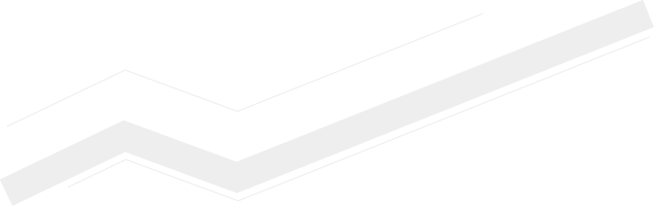
MMK Group financial statements
Key consolidated results for Q1 2017
(USD mln)
 | Q1 2017 | Q4 2016 | % | Q1 2017 | Q1 2016 | %
Revenue | 1,660 | 1,550 | 7.1% | 1,660 | 1,050 | 58.1%
Cost of sales | -1,171 | -1,039 | 12.7% | -1,171 | -789 | 48.4%
Operating profit | 319 | 321 | -0.6% | 319 | 192 | 66.1%
EBITDA*, of which. | 452 | 456 | -0.9% | 452 | 219 | 106.4%
Steel segment | 423 | 423 | 0.0% | 423 | 196 | 115.8%
Steel segment (Turkey) | 11 | 8 | 37.5% | 11 | 11 | 0.0%
Coal segment | 24 | 27 | -11.1% | 24 | 12 | 100.0%
Consolidation effect | -6 | -2 | - | -6 | 0 | -
EBITDA margin | 27.2% | 29.4% |  | 27.2% | 20.9%
Profit/loss for the period | 241 | 208 | 15.9% | 241 | 157 | 53.5%
Free cash flow | 15 | 124 | -87.9% | 15 | 96 | -84.4%
* EBITDA adjusted to the positive effect from FMG stake sale
Net profit growth, high EBITDA margin
and low debt burden
- Net profit for Q1 2017 grew 15.9% q-o-q and 53.5% compared to Q1 2016.
- EBITDA margin for Q1 2017 amounted to 27.2%, close to its historic maximum.
- Cash and Cash Equivalents at the end of the period amounted to USD 385 mln, up 25% on the levels seen as at 31.12.2016.
- Net debt remained virtually unchanged at USD 187 mln, maintaining the net debt/EBITDA ratio at 0.1x.
- Free cash flow for Q1 2017 amounted to USD 15 mln.

Q1 2017 highlights vs Q4 2016
Revenue increased in Q1 2017, due to the fact that the average dollar price was 14.5% higher than the previous quarter. The increase in steel prices took place against the backdrop of higher average prices for raw materials and the stronger rouble.
Cost of sales in Q1 2017 grew at a faster pace than revenue.
EBITDA remained almost unchanged on Q4 2016 (despite reduced finished products sales volumes) and amounted to USD 452 mln. The EBITDA margin fell q-o-q, but stayed high at 27.2%.
Quarterly profit amounted to USD 241 mln, an increase of 15.9% q-o-q.
Free cash flow (FCF) amounted to USD 15 mln. The main factor negatively impacting this was the increased cash outflow to working capital of USD 211 mln. However, a reduction in CAPEX of USD 64 mln supported FCF.

Q1 2017 highlights vs Q1 2016
Revenue increased 58.1% compared to Q1 2016 due to higher sales prices (up USD 249 per tonne, or 76.8%) and stable shipping volumes for finished products.
EBITDA grew 106.4% on the previous year as the rate of increase in cost of sales was less than the revenue growth rate.
Net profits grew 53.5% compared to Q1 2016, despite the preceding period’s profit was boosted by USD 25 mln due to the exchange rate. Excluding this non-cash factor, net profit in Q1 2017 would be 84.8% higher than the same period the previous year.

Balance-sheet and cash-flow highlights
Debt
The debt level for Q1 2017 grew USD 72 mln, or 14.4%, to USD 572 mln. However, this growth was fully compensated for by the growth in cash account balances.
At the end of Q1 the company had USD 385 mln cash balances (including cash and cash equivalents of USD 274 mln and short-term deposits of USD 111 mln).
As a result of the increase in financial liquidity, the company’s net debt fell further in Q1 2017, to USD 187 mln.
The reduction in net debt and increased EBITDA over the last 12 months delivered a net debt/EBITDA ratio of 0.09x, one of the lowest debt load ratios in the global metals industry.
The company’s high creditworthiness (low debt burden and high financial liquidity) is confirmed by the international ratings agencies Moody’s and Fitch Ratings.
Capital expenditure and cash flow
In Q1 2017, investment in fixed assets amounted to USD 121 mln. This fall on the preceding quarter is linked to the completion of planned maintenance at blast furnace No. 10, which began in Q4 2016.
In 2017, total CAPEX is planned at USD 590 mln, in line with the company’s long-term strategy of investing in its fixed assets.
The significant price increases for coking coal and iron ore, steel price recovery, and the strengthened rouble relation to the USD, led to a growth of accounts recevable and price increase in USD for inventories. As a result, cash outflow to working capital for Q1 2017 amounted to USD 211 mln.
The increase in inventories and accounts receivable in USD put pressure on free cash flow. However, a reduction in CAPEX of USD 64 mln q-o-q boosted FCF, which amounted to USD 15 mln in Q1 2017.

MMK Group highlights by segment
Steel segment (Russia)
The steel segment’s total revenue in Q1 2017 was USD 1,587 mln, up 7.7% q-o-q. The reduced sales volumes this quarter was balanced out by the better product mix and higher average sales price.
Segment EBITDA in Q1 2017 amounted to USD 423 mln, unchanged on the previous quarter.
The cash cost of a tonne of slab in Q1 2017 amounted to USD 301 (up USD 66 or 28.1% q-o-q). This growth was mainly due to higher prices for key raw materials (+ USD 39 per tonne) and the stronger rouble (+USD 20 per tonne).
Steel segment (Turkey)
MMK Metalurji’s revenue for Q1 2017 was USD 150 mln, slightly higher than the preceding quarter, despite smaller sales volumes.
Despite ongoing political instability ahead of referendum, the domestic market has broadly followed international pricing trends. EBITDA for Q1 2017 amounted to USD 11 mln, an increase of 37.5% q-o-q. Another important factor supporting the company’s EBITDA was the increase in export sales volumes compared to the average export sales in 2016 (chiefly to Europe and the USA). This increase is related to the positive pricing environment and substitution of imports from China with supplies from Turkey after import duties against Chinees steel were imposed in EU.
The stabilization of the political situation after elections in April 2017 will make it possible to forecast increasing sales volumes in Q2 2017, which will further boost the company’s finances.
Coal segment
The revenue generated by the coal segment in Q1 2017 grew 11.8% q-o-q, and amounted to USD 85 mln. This increase in revenue took place against a 17.1% reduction in the coking coal sale and was caused by a significant increase in coking coal price.
EBITDA for Q1 2017 fell USD 3 mln (or 11.1% q-o-q) and amounted to USD 24 mln. This reduction was largely related to reduced sales volumes for concentrate produced from the company’s own coal (due to the reduction in coal mining in Q1 2017) and increase of coal purchase for additional charging, given higher prices.
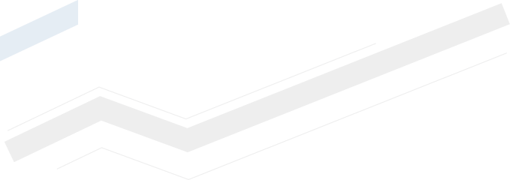
Dividends
On 21 April 2017, MMK’s Board of Directors recommended that the Annual General Meeting of Shareholders pay dividends on H2 2016 of RUB 1.242 per ordinary share, which amounts to 60% of Free Cash Flow of the company for that period.
This sum includes the distribution among the shareholders of part of the profit from the sale of FMG shares. Thus the total amount of dividends paid by MMK on 2016 could amount to around USD 370 mln.
Endorsing the company’s plan for greater and more frequent distribution of profits among shareholders, the Board of Directors confirmed the new version of the dividend policy which stipulates that no less than 50% of FCF should be awarded as dividends.
Market outlook
Currently company management sees slowing domestic demand linked to high levels of reserves held by traders. By June 2017 this situation should change as stockpiles fall and the demand for steel on the domestic market returns to its usual seasonal level.
In 2017, the demand for steel in Russia is expected to recover 1-2% on 2016 levels.

ММК management will hold a conference call on these financial statements on 11 May 2017 at 3 pm Moscow time (1 pm London time, 8 am New York time).
The conference call dial-in numbers are:
UK
+44 (0)330 336 9108 (Local access) / 0800 279 6839 (Toll free)
Russia
+7 495 213 1767 (Local access) / 8 800 500 9283 (Toll free)
US
+1 719-325-2230 (Local access) / 888-394-8218 (Toll free)

Conference ID: 9918137
The call recording will be available for seven days via the following numbers:
UK
+44 (0) 207 984 7568 (Local access) / 0 808 101 1153 (Toll free)
Russia
8 10 800 2702 1012 (Toll free)
USA
+1 719-457-0820 (Local access) / 888-203-1112 (Toll free)

Conference ID: 9918137

A presentation of the financial results and the IFRS financial statements can be found at: http://mmk.ru/for_investor/financial_statements/
OJSC MMK is one of the world's largest steel producers and a leading Russian metals company. The company's operations in Russia include a large steel producing complex encompassing the entire production chain, from preparation of iron ore to downstream processing of rolled steel. MMK turns out a broad range of steel products with a predominant share of high-value-added products.

Contacts
In 2016, MMK Group’s revenue amounted to
USD 5,630 bln
In 2016, MMK Group produced
12.5 mln t
Of steel
11.6 mln t
Of commercial metal products
EBITDA
1.956 bln $
Investor Relations Department
Andrey Serov
+7 3519 24-52-97
serov.ae@mmk.ru
Communications department
Dmitry Kuchumov Dmitry Bulin
+7 499 238-26-13 +7 499 238-26-13

kuchumov.do@mmk.ru bulin.dn@mmk.ru

