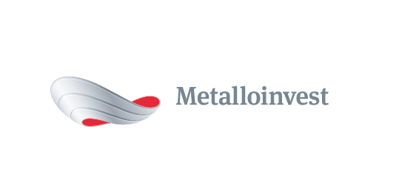 PRESS RELEASE

Metalloinvest increases pellet shipments to NLMK
19 August 2016, Moscow – Metalloinvest is increasing shipments of pellets to Novolipetsk Steel (NLMK) by 900,000 tonnes in the second half of 2016. Lebedinsky GOK and Mikhailovsky GOK will supply the products to NLMK’s main production site in Lipetsk. The total volume of pellet shipments this year will amount to 5.4 million tonnes.
Andrey Varichev, CEO of Management Company Metalloinvest, commented: “Metalloinvest’s production capacities allow it to meet growing domestic demand for high-quality iron ore products, which is one of our strategic priorities. According to the terms of this latest agreement, we will increase pellet shipments to NLMK, with whom we enjoy a longstanding and mutually beneficial partnership.”
The long-term pellet supply contract, which was signed in 2011, was extended until 31 December 2016. The pricing under the contract takes into account current market indicators, as well as global market price trends.
# # #
Metalloinvest (www.metalloinvest.com) is a leading global iron ore and HBI producer and supplier, and one of the regional high quality steel producers. The Company has the world’s second largest measured iron ore reserve base under its operation with the key-note iron ore production cost efficiency.

Metalloinvest is wholly owned by USM Holdings. Alisher Usmanov is the major beneficiary of USM Holdings (48%), with other major beneficiaries being the companies of Vladimir Skoch (30%) and Farhad Moshiri (10%).

For further information, please contact:
Corporate Communications Department
Dmitry Kravchenko
+7 (495) 981-55-55
pr@metalloinvest.com

