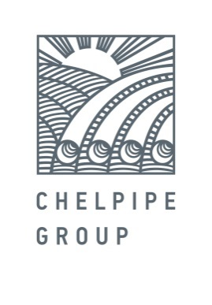

**October 10, 2017 PRESS RELEASE**

**ChelPipe Group will supply large diameter pipes to Romania for the first time**

ChelPipe Group will supply large diameter pipes (LDP) to OMV, the largest oil company in Central Europe, for the first time. The order includes 850 tons of pipes, 508 mm in diameter with a wall thickness of 14.2 mm and with a three-layer polyethylene coating, and 1,620 tons of pipes with a wall thickness of 11 mm. The LDPs will be manufactured at the Vysota 239 LDP rolling mill at the Chelyabinsk Pipe Plant (a ChelPipe subsidiary).

Pipes will be used to repair an existing OMV gas pipeline and to construct a new one in Romania. The job involves a challenging lead time for production and delivery. Under the terms of the contract concluded in September, ChelPipe Group will supply the first batch of pipes in October, 2017. To ensure prompt LDP delivery, the company has developed a multimodal logistics system involving transportation by rail, sea, and road.

"ChelPipe Group won the tender by offering the Austrian company OMV the rapid production of a product that meets all their requirements. This victory in the competitive struggle with European manufacturers once again emphasizes the high quality of our product and the demand for our product, both on the internal and external markets," commented Denis Prikhodko, ChelPipe Group Sales Director.

Large diameter pipes manufactured at the Vysota 239 LDP rolling mill at the Chelyabinsk Pipe Plant have been supplied to the following major pipeline construction projects: Power of Siberia, Southern Corridor, Bovanenko–Ukhta, Beyneu–Bozoy–Shymkent, Zapolyarye-Purpe, Kuyumba-Taishet, V. Filanovsky gas and condensate field. Today, ChelPipe Group supplies LDPs manufactured at the Vysota 239 to Nord Stream 2, an international pipeline construction project. In addition, pipes manufactured at the Vysota 239 have been used in the construction of large sports facilities: The Olympic Speed-skating Center in Sochi and the stadiums that will host the 2018 FIFA World Cup.

OMV Group is the largest oil and gas company in Central Europe. The gas pipeline network supplies gas not only to Austria but also to Germany, Italy, France, Slovenia, Croatia, and Hungary. As an important part of the European gas pipeline network, the OMV pipeline system is also connected to the gas supply systems of these countries.

***For reference:***

***ChelPipe Group*** *is a leading industrial group of companies of the Russian iron and steel industry. At year-end 2016, the Company had 16.5% share in the overall shipments by Russian pipe manufacturers ChelPipe Group consists of the following ferrous metallurgy plants and companies: the Chelyabinsk Pipe plant, Pervouralsk Pipe plant, a storage facility used as an outlet to sell tubular goods in the regions, META scrap metal collection and processing company; mainline equipment manufacturers: Pipeline Bends, ETERNO, MSA (Czech Republic); its oilfield service business represented by Rimera.*

***Leonid Bogomolov***

*Head of External Communications Department*

*tel.: 8(495)775-35-55; mob.: 8(903)593-63-71*

[*Leonid.Bogomolov@chelpipe.ru*](mailto:Leonid.Bogomolov@chelpipe.ru)