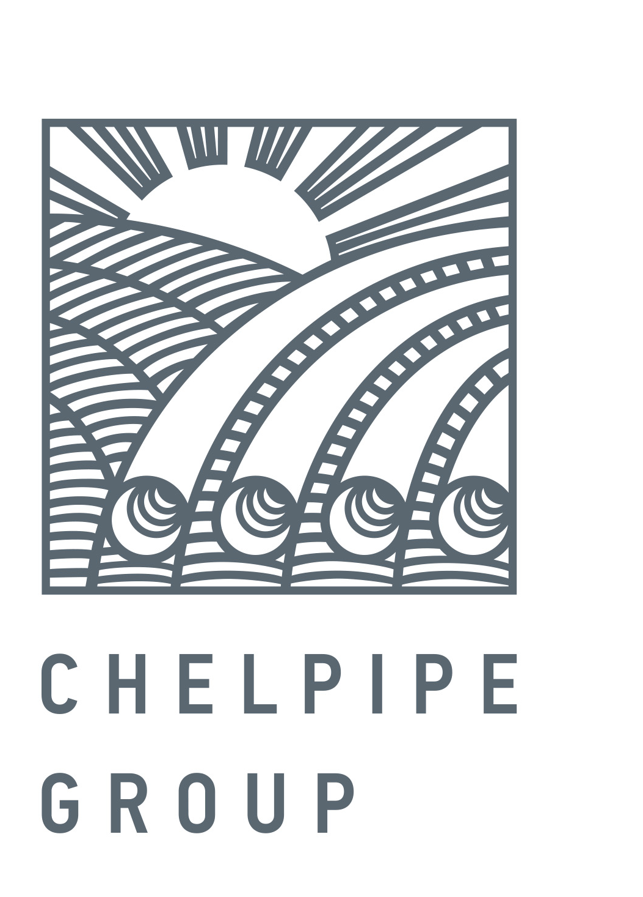

February 09, 2017 PRESS RELEASE

ChelPipe successfully completes second bond issue within framework of exchange-traded bond program
Public Joint Stock Company Chelyabinsk Pipe plant (ChelPipe), the leading Russian manufacturer of pipe products and a provider of integrated solutions for energy companies, announces the successful conclusion of book-building for the company’s second issue of exchange-traded bonds (BO series 001P-02) in a total nominal volume of RUB 5 bln, placed under the Program.
The exchange-traded bonds are structured according to the classical scheme with a 182-day coupon period and bullet repayment at the end of the term. The par value of each bond is RUB 1,000. The maturity term is 5 years after the placement date.
The new issue generated considerable interest from a wide range of investors including banks, asset management, insurance and investment companies, and individuals. The significant demand allowed the preliminary coupon guidance range to be readjusted downward three times throughout the course of the book-building, eventually settling at 9.85% (YTM 10.09%, 200 bps premium to OFZs).
During the book-building we received 45 orders from investors with overall demand exceeding 18 billion rubles.
“We are very satisfied with the results of the placement and are thankful to our investors for placing their faith in us. The success of this deal lies in the systematic work of the ChelPipe team to improve our operating results and debt structure”, commented Valery Borisov, ChelPipe CFO.
The technical placement of the bonds will take place on February 15, 2017 on the Moscow Exchange.
The book runners of the deal are Gazprombank, VTB Capital, Raiffeisenbank and ROSBANK. The placement agent is Gazprombank.
The Exchange-Traded Bonds Program with a nominal value of RUB 50 bln or the equivalent in foreign currency was registered on November 29, 2016.
For reference:
ChelPipe Group is a leading industrial group of companies of the Russian iron and steel industry. At year-end 2015, the Company had 17.7% share in the overall shipments by Russian pipe manufacturers ChelPipe Group consists of the following ferrous metallurgy plants and companies: the Chelyabinsk Pipe plant, Pervouralsk Pipe plant, a storage facility used as an outlet to sell tubular goods in the regions, META scrap metal collection and processing company; mainline equipment manufacturers: Pipeline Bends, ETERNO, MSA (Czech Republic); its oilfield service business represented by Rimera.

Leonid Bogomolov
Head of external communications
tel.: 8(495)775-35-55; mob.: 8(903)593-63-71
Leonid.Bogomolov@chelpipe.ru

