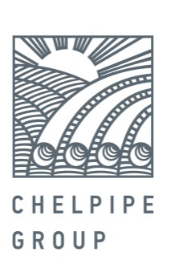

March 22, 2017 PRESS RELEASE

ChelPipe Group Introduces a New Type of Pipe for Oil and Gas Fields

ChelPipe Group had developed a new type of pipe with premium, high-seal ChT-2C thread connection. The new product will be manufactured at the finishing center for oil-grade pipe production at Pervouralsk Pipe plant (a ChelPipe subsidiary). Supply will officially begin in H2 2017.
The connection strength is designed for the pipes to be used in fields with complex production conditions. ChT-2C can withstand combined loads: tension, compression, internal and external pressure.
The reliability of the new connection is approved by the VNIIGAZ (All-Union Research Institute of Natural Gas) Russian testing center, as well as by an accredited testing center in Germany in accordance with ISO 13679/API 5C5 procedures. Test results revealed that ChT-2C performs better in a number of indicators compared to its foreign and Russian analogs.
"By launching this product on the market, ChelPipe group will be able to etch out its share in the segment of second-gen premium class connections. The development of new types of OCTG pipes with premium threads helps the company significantly increase the supply of high-margin products," notes Denis Prihodko, ChelPipe Group Sales Director.
ChelPipe Group has been supplying OCTG type pipes with premium class thread connections since 2012. In 2016 ChelPipe Group increased the shipment of pipes with Premium threads by 10 %. The company began to design the new ChT-2C connection in 2014. ChelPipe Group also provides after-sales services for engineering and technical support of tubing and casing makeup.

For reference:

ChelPipe Group is a leading industrial group of companies of the Russian iron and steel industry. At year-end 2016, the Company had 16.5% share in the overall shipments by Russian pipe manufacturers ChelPipe Group consists of the following ferrous metallurgy plants and companies: the Chelyabinsk Pipe plant, Pervouralsk Pipe plant, a storage facility used as an outlet to sell tubular goods in the regions, META scrap metal collection and processing company; mainline equipment manufacturers: Pipeline Bends, ETERNO, MSA (Czech Republic); its oilfield service business represented by Rimera.

Leonid Bogomolov
Head of External Communications Department
tel.: 8(495)775-35-55; mob.: 8(903)593-63-71
Leonid.Bogomolov@chelpipe.ru

