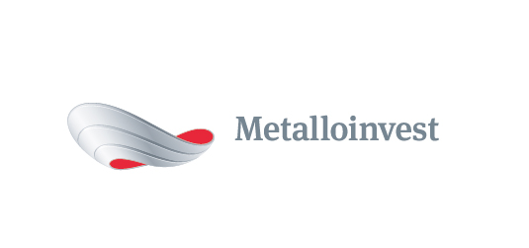 PRESS RELEASE

Metalloinvest signs long-term contract with Severstal to supply iron ore concentrate

16 August 2017, Moscow - Metalloinvest and Severstal have signed a new long-term contract for the supply of 1.8 mn tonnes of iron ore concentrate, valid until 30 June 2018.
Deliveries will be made from Lebedinsky GOK (part of Metalloinvest). The contract also covers the supply of dry iron ore concentrate in the winter.
Pricing will be determined through a formula based on market indicators for iron ore prices in both global and domestic markets.
Nazim Efendiev, First Deputy CEO, Head of Sales, Management Company Metalloinvest, commented: "Metalloinvest's production facilities are capable of meeting the growing demand of Russian steel companies for high-quality iron ore. The new contract continues the successful and long-lasting partnership between Metalloinvest and Severstal.”
Dmitry Sakhno, Director, of Raw Material Sales, Procurement and Logistics, Severstal, noted: "Severstal has been purchasing iron ore from Metalloinvest since 2010. This new contract is a testament to our absolute satisfaction with the quality of the products."

# # #
Metalloinvest is a leading global iron ore and merchant HBI producer and supplier, and one of the regional producers of high-quality steel. The Company has the world's second-largest measured iron ore reserve base and is one of the lowest-cost iron ore producers.
Metalloinvest is wholly owned by USM Holdings. Alisher Usmanov is the major beneficiary of USM Holdings (49%), with other major beneficiaries being the companies of Vladimir Skoch (30%) and Farhad Moshiri (10%).

For further information, please contact:
Corporate Communications Department
Dmitry Kravchenko
+7 (495) 981-55-55
pr@metalloinvest.com

