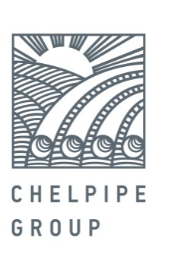

March 23, 2017 PRESS RELEASE

ChelPipe successfully completes the first ever 7 year bond within the BB- corporate segment

Public Joint Stock Company Chelyabinsk Pipe plant (ChelPipe), the leading Russian manufacturer of pipe products and a provider of integrated solutions for energy companies, announces the successful conclusion of book-building for the company’s third issue of exchange-traded bonds (BO series 001P-03) in a total nominal volume of RUB 5 bln, placed under the Program.
The exchange-traded bonds are structured according to the a unique scheme with a 91-day coupon period and bullet repayment at the end of the term. The par value of each bond is RUB 1,000. The maturity term is 7 years after the placement date.
The new issue generated considerable interest from a wide range of investors including banks, asset management, insurance and investment companies, and individuals. The significant demand allowed the preliminary coupon guidance range to be readjusted downward twice over the course of the book-building, eventually settling at 9.70% (YTM 10.06%, 197 bps premium to OFZs).
During the book-building we received 25 orders from investors with overall demand exceeding 8 billion rubles.
“ChelPipe has become the first corporate issuer of 7 year bonds in the BB- segment rating. Considerable demand for the third bond issue allowed the company to close the order book at a lower boundary than initially anticipated and confirmed the high level of investment attractiveness of our company”, commented Valery Borisov, ChelPipe CFO.
The technical placement of the bonds will take place on March 30, 2017 on the Moscow Exchange.
The book runners of the deal are Gazprombank, VTB Capital, Unicredit Bank and Sberbank. The placement agent is Gazprombank.
The Exchange-Traded Bonds Program with a nominal value of RUB 50 bln or the equivalent in foreign currency was registered on November 29, 2016.

For reference:

ChelPipe Group is a leading industrial group of companies of the Russian iron and steel industry. At year-end 2016, the Company had 16.5% share in the overall shipments by Russian pipe manufacturers ChelPipe Group consists of the following ferrous metallurgy plants and companies: the Chelyabinsk Pipe plant, Pervouralsk Pipe plant, a storage facility used as an outlet to sell tubular goods in the regions, META scrap metal collection and processing company; mainline equipment manufacturers: Pipeline Bends, ETERNO, MSA (Czech Republic); its oilfield service business represented by Rimera.

Leonid Bogomolov
Head of External Communications Department
tel.: 8(495)775-35-55; mob.: 8(903)593-63-71
Leonid.Bogomolov@chelpipe.ru

