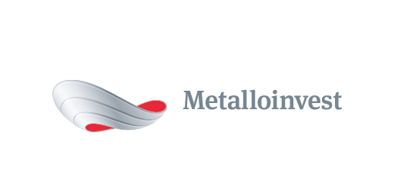 PRESS RELEASE
Ural Steel is launching a new product
6 February 2017, Moscow – Ural Steel (part of Metalloinvest) is launching a new product, the slag pot.
The first trial version of a slag pot for the Ural Steel pig iron facility was cast in June 2016 at the modular casting unit in the enterprise machine shop. Over seven months of use, the slag pot has withstood over 500 loads and continues to be in use.
Andrey Ugarov, First Deputy CEO, Chief Operating Officer of Management Company Metalloinvest, commented: “Testing the product has enabled us to draw a conclusion on its outstanding technical qualities. Metalloinvest’s use of the new Ural Steel product will mean that we will no longer be required to purchase slag pots from external suppliers. This will significantly increase the Company’s operational efficiency.”
Currently, more than 30 slag pots are purchased for Metalloinvest’s metallurgical enterprises annually.
The successful experience served as a launching pad for the development of large-scale casting at Ural Steel. A second slag pot was produced for the electric arc furnace shortly after the first edition for the blast furnace. With this technique for manufacturing casting forms, the finished products have practical differences: the slag pot for the blast furnace measures 16.5 cubic metres, whereas the version for the electric arc furnace is 16 cubic meters.
Ural Steel plans to arrange the regular delivery of slag pots to OEMK (part of Metalloinvest), as well as launching wide-scale production for Lebedinsky GOK with the further expansion of its product range.
The launch and development of the new product will enable it to be supplied to external metals and mining companies.
# # #
Metalloinvest is a leading global iron ore and merchant HBI producer and supplier, and one of the regional producers of high-quality steel. The Company has the world's second-largest measured iron ore reserve base and is one of the lowest-cost iron ore producers.
Metalloinvest is wholly owned by USM Holdings. Alisher Usmanov is the major beneficiary of USM Holdings (49%), with other major beneficiaries being the companies of Vladimir Skoch (30%) and Farhad Moshiri (10%).

For further information, please contact:
Corporate Communications Department
Dmitry Kravchenko
+7 (495) 981-55-55
pr@metalloinvest.com

