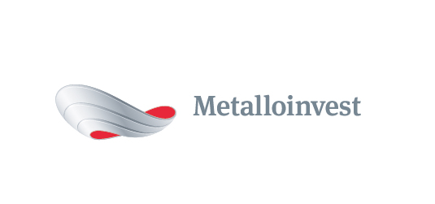 PRESS RELEASE

Metalloinvest launches Ural Steel industrial waste landfill

18 August 2017, Moscow - Ural Steel (part of Metalloinvest) has launched an industrial waste landfill facility. Approximately 160 mn roubles have been invested in the project.
Andrey Ugarov, First Deputy CEO, COO, Management Company Metalloinvest, commented: "Commissioning this new landfill will allow Ural Steel to improve the environmental safety of its production process. Minimising the impact of its operations on the environment is an unconditional priority for the Company. All Metalloinvest enterprises annually implement measures to reduce waste generation and increase the reuse of waste products."
The landfill is designed for the safe storage of industrial and domestic waste, facilitating its efficient processing further down the line. The facility is designed for 25 years of operation.
The landfill was built taking into account all modern ecological, sanitary and epidemiological requirements, mitigating any negative impact on the environment.
Ural Steel used modern technological and construction methodologies during the building of the facility, using cutting-edge materials with low filtration coefficients. A drainage system has been installed underneath the disposal area for waste containing petroleum products, to prevent the ingress of pollutants into groundwater. A system of channels for collecting and draining meltwater and atmospheric precipitation has been built within the landfill area. Hydropneumatic tanks have been installed at the facility to assess its impact on the environment, as well as video surveillance and firefighting systems. Industrial waste that enters the landfill is automatically accounted for at the entrance and sorted prior to storage; oily waste is rendered harmless on a special site.
Elena Timofeeva, State Inspector for the Orenburg branch of the Federal Service for Supervision of Use of Natural Resources (Rosprirodnadzor), commented: "Environmental management experts hold Metalloinvest’s fundamental position on waste management in high regard. Metalloinvest is currently one of few Russian companies that have addressed the issue of responsibly disposing of industrial waste at its enterprises, including Ural Steel. The construction of such an environmentally-friendly facility is expensive and complex, but essential in order to improve the environmental situation of both the Orenburg region and Russia as a whole."

Notes to editors:
The primary method of minimising the impact of production on the environment is the systematic introduction of modern technologies and equipment. Thanks to the modernisation of the production process at Ural Steel in recent years, the enterprise has been able to significantly reduce its man-made impact on the environment. The implementation of such environmental measures at the plant results in a major reduction in gross emissions of pollutants. The effectiveness of the environmental measures at Ural Steel was reaffirmed in April 2017, during the certification audit for the compliance of the environmental management system with the international standard ISO 14001: 2015.

# # #
Metalloinvest is a leading global iron ore and merchant HBI producer and supplier, and one of the regional producers of high-quality steel. The Company has the world's second-largest measured iron ore reserve base and is one of the lowest-cost iron ore producers.
Metalloinvest is wholly owned by USM Holdings. Alisher Usmanov is the major beneficiary of USM Holdings (49%), with other major beneficiaries being the companies of Vladimir Skoch (30%) and Farhad Moshiri (10%).

For further information, please contact:
Corporate Communications Department
Dmitry Kravchenko
+7 (495) 981-55-55
pr@metalloinvest.com

